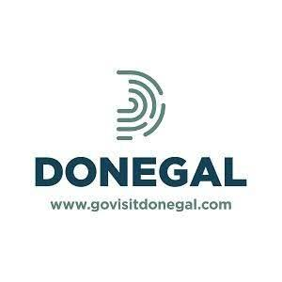

DONEGAL TOURISM ASSOCIATE MEMBERSHIP APPLICATION 2024
TO APPLY, PLEASE COMPLETE AND RETURN THE FORM BELOW

Business Name
Contact Name
Position
Address
Telephone Number
Email
Website
Category
for example
- Accommodation Provider
- Restaurant
- Activity Provider
- Adventure Tourism
Signature
Date

Annual Membership Fee €20
You can pay by bank transfer:
Bank Name: AIB, 61 Upper Main Street, Letterkenny
Account Name: County Donegal Tourism Limited
Account Number: 08717-022 Sort Code: 93-73-47
IBAN: IE65 AIBK 9373 4708 7170 22 (BIC: AIBKIE2D)

Alternatively, you can pay by cheque; please make cheques payable to: Donegal Tourism Ltd
and post, together with the application form, to Donegal Tourism Ltd, Donegal Public Service Centre, Drumlonagher, Donegal Town, Co Donegal

□ GDPR: I give Donegal Tourism my consent to keep my details on file and add my e-mail address to the MailChimp database of contacts.
You can pay by bank transfer:
Bank Name: AIB, 61 Upper Main Street, Letterkenny
Account Name: County Donegal Tourism Limited
Account Number: 08717-022 Sort Code: 93-73-47
IBAN: IE65 AIBK 9373 4708 7170 22 (BIC: AIBKIE2D)
You can pay by bank transfer:
Bank Name: AIB, 61 Upper Main Street, Letterkenny
Account Name: County Donegal Tourism Limited
Account Number: 08717-022 Sort Code: 93-73-47
IBAN: IE65 AIBK 9373 4708 7170 22 (BIC: AIBKIE2D)

